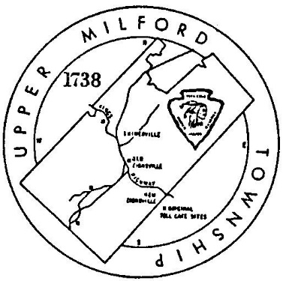
Upper Milford Township
Planning Commission

Special Meeting Agenda
Monday October 25th, 2021

Meeting brought to order at 7:00 PM

ANNOUNCEMENT: This is a joint meeting of the Board of Supervisors and the Planning Commission to discuss the proposed zoning change for property located at 4650 Indian Creek Road, Emmaus, PA

Public Comment:

Other Business:

Discussion Item Only: Upper Milford Township Board of Supervisors request for discussion on the 4650 Indian Creek Road Emmaus Zoning Change Request.

Adjournment

NO DISCUSSION REQUIRED
Plans with prior approvals or requiring additional information.

SUBDIVISIONS:
Indian Creek Industrial Park Subdivision
Jerome Goldstein Minor Subdivision
Estates at Maple Ridge
Estates at Maple Ridge COSDO
Dale & Lucy Dries Subdivision

LOT LINE ADJUSTMENTS
None

LAND DEVELOPMENT / SITE PLANS:
4054 Chestnut St. MPI Diagnostics
Indian Creek Industrial Park Lot 10

The next regularly scheduled meeting of the Upper Milford Township Planning Commission will be held on Monday November 1st, 2021 at 7:30 p.m. in the Upper Milford Township Building Old Zionsville, PA.

