Western District – Station 19

14 - Calls:

1 Dispatched and cancelled

3 Motor vehicle w/injuries

5 Building Fire

2 Passenger Vehicle Fire

1 Medical Assist, Assist EMS

1 Motor Vehicle w/no injuries

1 Carbon Monoxide Detector Act.

- 5 - automatic/mutual aid given
- 0 – Aid Received

Ambulance response calls for Upper Milford Township

Emmaus Ambulance – 22 Calls
Macungie Ambulance - 30 Calls

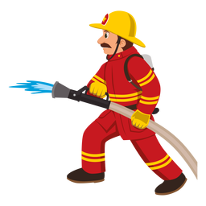

Citizen’s Fire Company – Station 28

25 - Calls:

2 Building Fire

1 Passenger Vehicle Fire

2 Road Freight or Transport fire

1 Brush or Grass mix Fire

7 Medical Assist, Assist EMS

3 Motor Vehicle with Injuries

2 Extrication of Victim from Vehicle

1 carbon Monoxide Incident

3 Assist Police or Other Agency

1 Smoke Scare, Odor of Smoke

2 Alarm System Sounded due to
Malfunction

- 24 - automatic/mutual aid given
- 0 - automatic/mutual aid received
