Western District – Station 19

XX - Calls:

No call report due to change over
of reporting platform

- 0- automatic/mutual aid given
- 0 – Aid Received

Ambulance response calls for Upper Milford Township

Emmaus Ambulance – 25 Calls
Macungie Ambulance -- 21 Calls

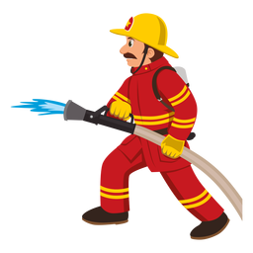

Citizen’s Fire Company – Station 28

XX - Calls:

No call report due to change over
of reporting platform

- 0 - automatic/mutual aid given
- 0 - automatic/mutual aid received
